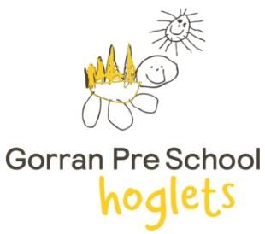
NEWSLETTER

Welcome to Hoglets, we would like to welcome you all to a new term.

We would like to say how pleased we are that all the children new and old have settled into preschool really well.



Please see attached our new long term planning goal and our learning topics. These include songs and books that you can learn along with your child.

We have started the term looking at ourselves and families. We will then move on to seasonal changes.

We would like to congratulate Aimee on her news of a new baby arriving in the new year. An exciting journey ahead for Aimee and her husband Johan.

Please can we ask that parents/carers to be prompt getting to preschool for dropping off at 8:45am and picking up at 11:45am, 1:15pm and 3:30pm.
This helps children to settle into the day easier and help with transitions.
We have spoke to big school and they have assured us the school gate on the footpath will be opened at 3:30pm and you will have enough time to get your child from preschool and big school.

Informing preschool of any changes or queries:

- If your child is sick, please let us know by email or message.
- If you are going away on holiday then please email Michelle so we are aware of when your child will not be here and can staff accordingly.
- If you would like to swap a session or change any days then please email Michelle and Lesley.
- If you have any queries regarding invoices, please email Lesley.

We have a whatsapp group and a facebook page so please look out on these for any updates.


Make sure your child has the following;
- Wellies
- Winter hats
- Coats

- 2 x adequate change of clothes
- Water Bottle with Water
- Wet weather gear
We need all children to be dressed appropriately for the weather and to be prepared for going out in all weathers.
If your child has a packed lunch please ensure it is healthy and all foods are cut up appropriately.

Please empty book bags daily as we send important information home in these!

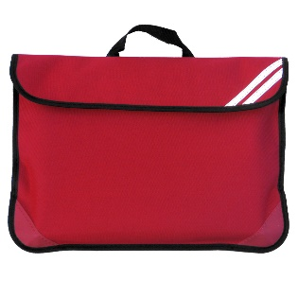

Please pin me to your fridge!
Important dates

14th Oct – AGM 7pm (all welcome)
24th Oct – Break up for half term
3rd Nov – Back to preschool
4th Nov – Open evening at preschool 7pm (all welcome)

11th Nov – Parents invited in to do activity with their children 2:30pm-3:30pm (Tuesday children only)
10th Dec – Nativity 10am
12th Dec – Sleigh night
16th Dec – Xmas party morning (all children welcome but if this isn’t your childs day, please pick up at 11:45am)
17th Dec – Xmas dinner
19th Dec – Break up for Xmas holidays

5th Jan – Back to preschool
13th Feb – Break up for half term

23rd Feb – Back to preschool
2nd April – Break up for Easter
20th April – Back to preschool
4th May – Bank holiday
22nd May – Break up for half term
1st June – Back to preschool

