General Welfare Requirement: Organisation
Providers must plan and organise their systems to ensure that every child receives an enjoyable
and challenging learning and development experience that is tailored to meet their individual needs.

Gorran Pre School let-s
Administration
4.1 Admissions

Policy Statement
At Gorran Pre-School Hoglets it is our intention to make our setting accessible to children and families from all sections of the local community. We aim to ensure that all sections of our community have access to the setting through open, fair and clearly communicated procedures.

EYFS key themes and commitments
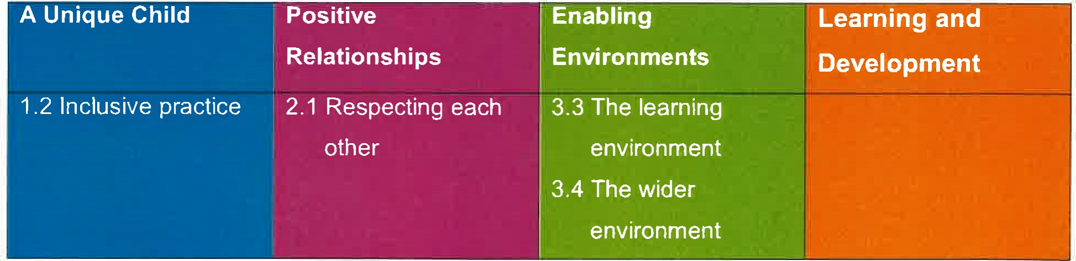

Procedures
We ensure that the existence of our setting is widely advertised in places accessible to all sections of the community and our website.
We ensure that information about our setting is accessible, in written and spoken form and, where appropriate, in more than one language. Where necessary, we will try to provide information in Braille, or through British Sign Language. We will provide translated written materials where language needs of families suggest this is required as well as access to an interpreter.
- We arrange our waiting list in birth order. In addition our policy may take into account the following:
the vicinity of the home to the setting; and siblings already attending the setting.
- We take children from two years of age.
- When financially viable, we keep a place vacant to accommodate an emergency admission.
We describe our setting and its practices in terms that make it clear that it welcomes both fathers and mothers, other relations and other carers, including childminders.
- We describe our setting and its practices in terms of how it treats each child and their family, having regard to their needs arising from their gender, special educational needs, disabilities, social background, religion, ethnicity or from English being a newly acquired additional language.
We describe our setting and its practices in terms of how it enables children and/or parents with disabilities to take part in the life of the setting.
We monitor the gender and ethnic background of children joining the group to ensure that our intake is representative of social diversity.
- We make our Equal Opportunities Policy widely known.
We consult with families about the opening times of the setting to ensure we accommodate a broad range of family need.
We are flexible about attendance patterns to accommodate the needs of individual children and families, providing these do not disrupt the pattern of continuity in the setting that provides

stability for all the children.
This policy was adopted at a meeting of

Held on
Date to be reviewed
Signed on behalf of the management committee
Name of signatory
Role of signatory (e.g. chair)

Gorran Preschool name of setting

October 2019 (date)

October 2020 (date)

Michelle Beard

Preschool Leader/Nominated Person

